**Unit #11 – The Circular Functions**

**Common Core Algebra II**

**Part I Questions**

1. Which of the following angles is coterminal with an angle of , assuming both angles are drawn in the standard position?

(1)  (3) 

(2)  (4) 

2. If drawn in the standard position, which of the following angles terminates in the third quadrant?

(1)  (3) 

(2)  (4) 

3. A rotation angle, drawn in standard position, measures . In which quadrant does its terminal ray lie?

(1) I (3) III

(2) II (4) IV

4. Which of the following has the same reference angle as ?

(1)  (3) 

(2)  (4) 

5. The radian angle  is equivalent to

(1)  (3) 

(2)  (4) 

6. The angle  can be written equivalently as which of the following in the radian system?

(1)  (3) 

(2)  (4) 

7. If the minute hand of a clock is 3.5 inches long and its tip rotates through a distance of 8 inches, then which of the following is closest to the angle that it rotates?

(1)  (3) 

(2)  (4) 

8. A goat is attached to a 12 foot long leash pulled tight and rotates through an angle of . Which of the following is closest to the distance that the goat travels?

(1) 23 ft (3) 41 ft

(2) 32 ft (4) 48 ft

9. A point lies on the unit circle whose *x*-coordinate is . If the point lies in the fourth quadrant, then which of the following is its *y*-coordinate?

(1)  (3) 

(2)  (4) 

10. The terminal ray of an angle drawn in standard position on the unit circle that measures  has coordinates of . Based on this information, what is the value of ?

(1)  (3) 

(2)  (4) 

11. For an angle *A* that terminates in the second quadrant, . Which of the following calculations would result in the value of ?

(1)  (3) 

(2)  (4) 

12. Which of the following could *not* be the value of the cosine of an angle?

(1)  (3) 

(2)  (4) 

13. If  is an angle such that  and  then which of the following is the value of ?

(1) 0.56 (3) 0.83

(2)  (4) 

14. If  then  ?

(1)  (3) 18

(2) 8 (4) 

15. If an angle has a positive cosine but a negative sine then it must terminate in which of the following quadrants?

(1) I (3) III

(2) II (4) IV

16. Which of the following represents the range of the function ?

(1)  (3) 

(2)  (4) 

17. Given the sinusoidal graph with coordinates shown below, which of the following is the value of its amplitude?

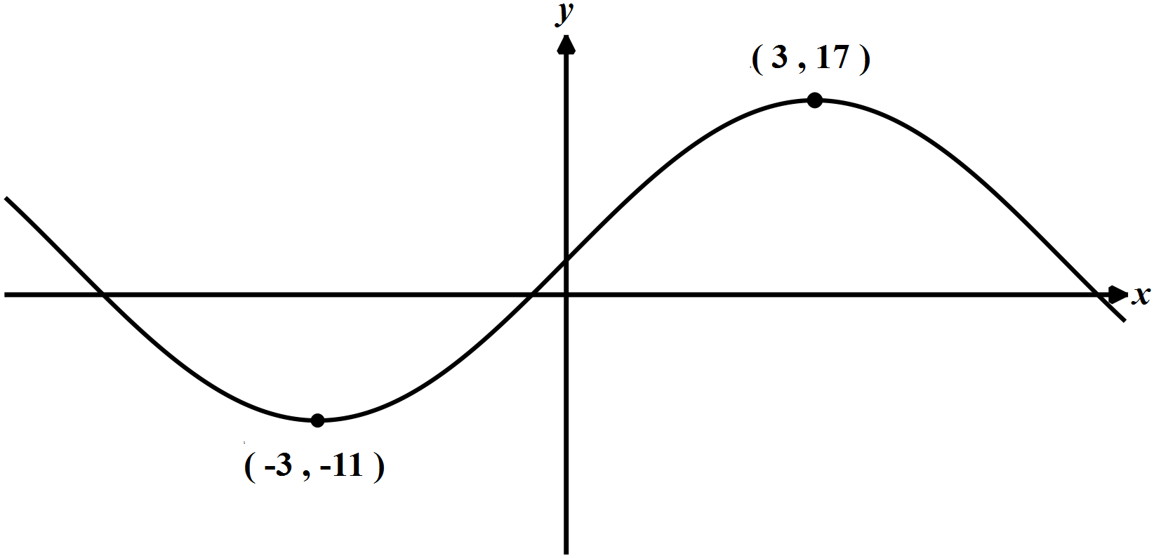

(1) 14 (3) 12

(2) 6 (4) 28

18. A periodic function has an equation . What is the horizontal distance between any two consecutive relative maximums on this graph?

(1) 10 (3) 8

(2)  (4) 

19. The graph shown below can be described using the equation . Which of the following is the value of ?

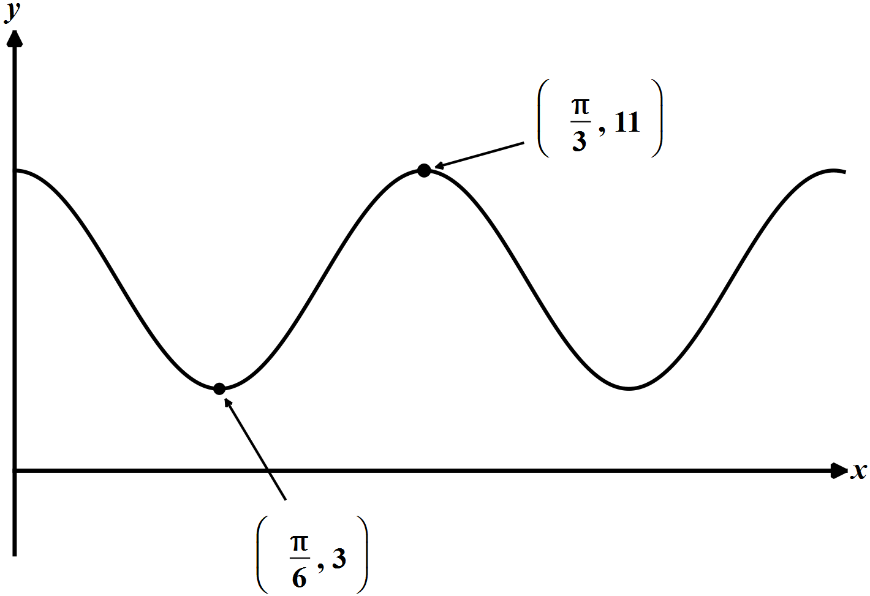

(1) 

(2) 13

(3) 11

(4) 

20. Which of the following lines would the graph of  *not* intersect?

(1)  (3) 

(2)  (4) 

21. A person riding a Ferris wheel at a local fair makes one complete trip around in 10 minutes. Their height can be modeled using a sine function of the form , where *t* is the amount of time the person has been traveling, in minutes. Which of the following must be the value of *B*?

(1) 10 (3) 

(2)  (4) 

22. The volume of water in a tank varies periodically. At  it is at its maximum of 650 gallons and at  it is at its minimum of 120 gallons. Which of the following functions would best model the volume of water in this tank as a function of time in hours?

(1) 

(2) 

(3) 

(4) 

23. The terminal ray of an angle drawn in standard position passes through the point  on the unit circle. Which of the following is closest to the tangent of this angle?

(1) .685 (3) 1.697

(2) 1.291 (4) 2.883

24. If  is an angle drawn in the standard position with its terminal ray landing in the fourth quadrant and , then which of the following is the exact value of ?

(1)  (3) 

(2)  (4) 

25. For the angle  it's known that  and . In which quadrant does the terminal ray of  lie?

(1) I (3) III

(2) II (4) IV

**Free Response Questions**

26. An angle drawn in standard position measures 10 radians. In what quadrant does its terminal ray lie? Show the reasoning that leads to your answer.

27. Given the following circle (note that it is **not** the **unit circle**) with the angle  marked, state the values of each of the following:

(a) The radius of the circle

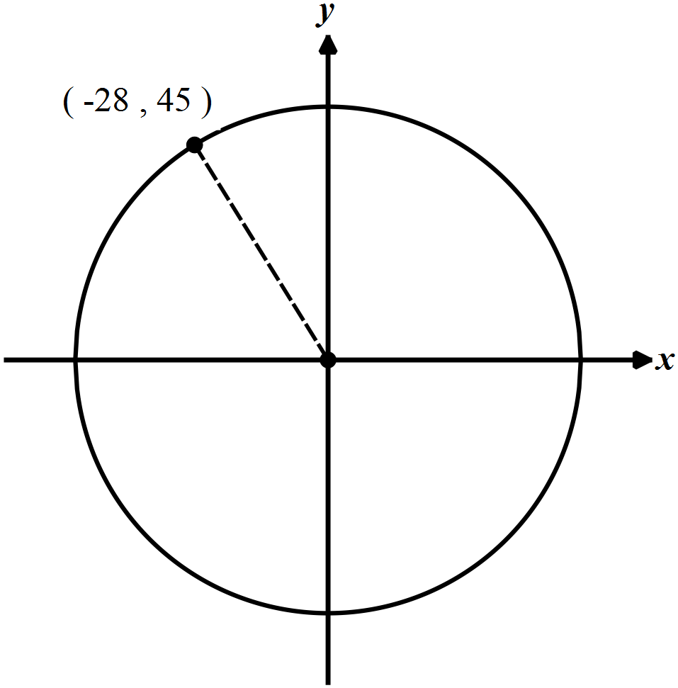



(b) 

(c) 

(d) 

(e) 

(f) 

(g) 

28. In the circle shown below,  and the length of the minor arc from point A to point C is 40. Find the exact measure of the marked angle  in terms of radians. Show how you arrived at your answer.

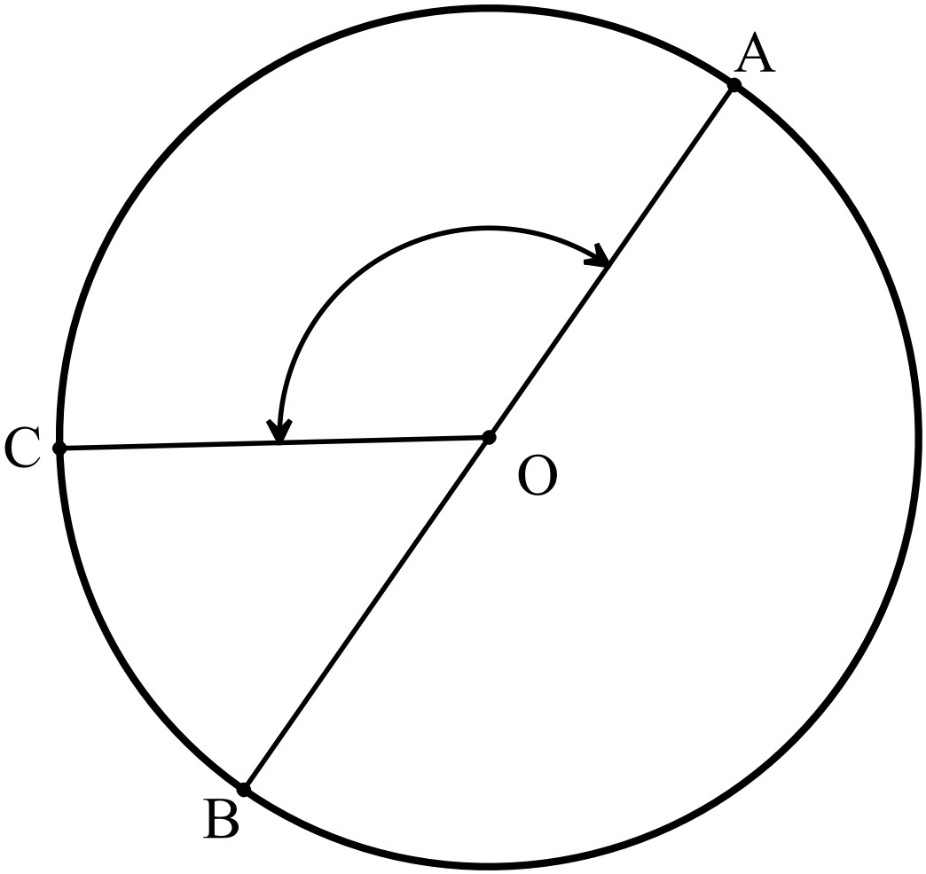



29. For an angle *A* it is known that  and . Determine the value of . Show how you arrived at your answer.

30. A portion of the unit circle is shown below. Based on this information, determine the value of  in exact form. Explain how you arrived at your answer.

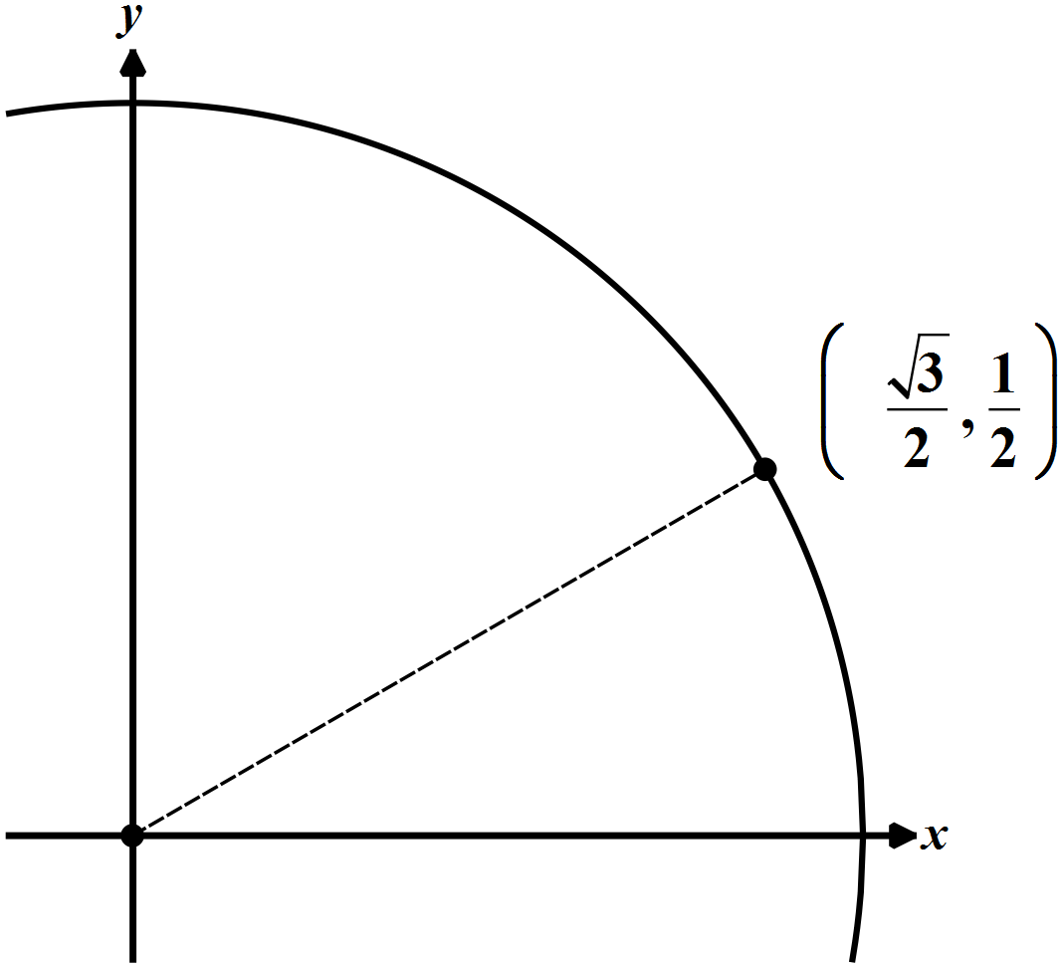



31. For the function , explain why the equation  would fail to have any solutions.

32. For the function , it is known that . Explain why  must also equal 7.

33. The graph shown below can be modeled using the equation . Determine the values of *A*, *B*, and *C*. Show how you arrived at your results.

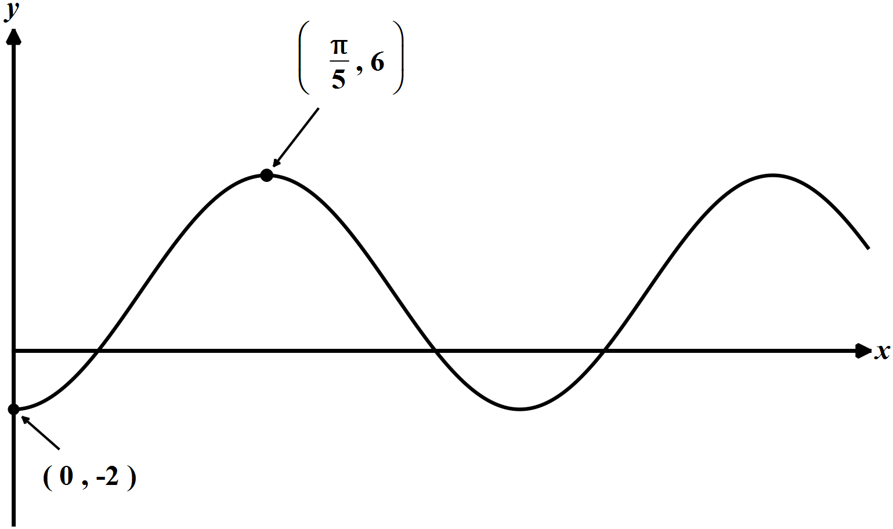

34. If the function  is graphed below, answer the following questions about point *D* marked.

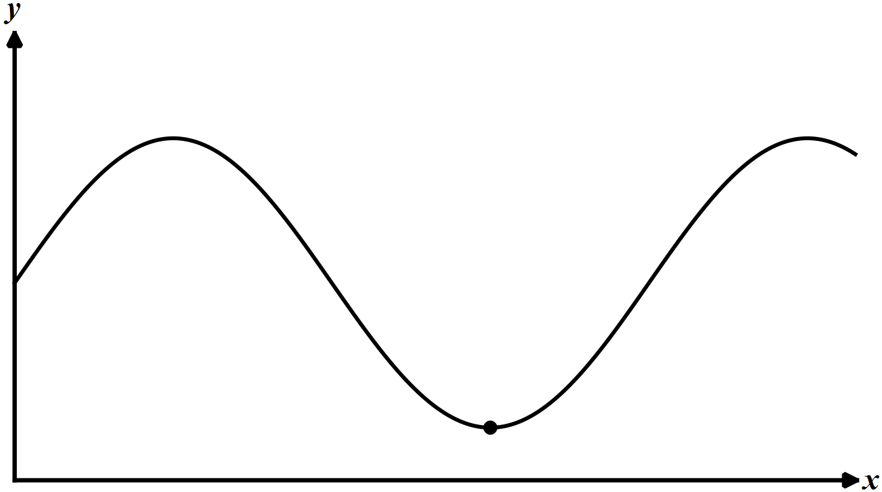

*D*

(a) What is the numerical value of the *x*-coordinate of point *D*? Show how you arrived at your answer.

(b) What is the *y*-coordinate of *D* in terms of the constants *A* and *C*?

35. A person's height, in feet above the ground, on a Ferris wheel can be modeled using the equation , where *t* is the time the rider has been on the wheel in minutes. What is the maximum height the rider reaches and the time it takes to first reach this height if they get on at . Explain how you arrived at your answer.